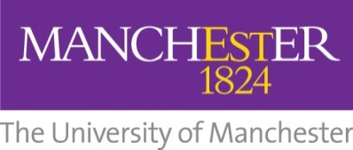

School of Arts, Languages and Cultures
Modern Hebrew Language Bursary Application Form
Please tick which course you would like to apply for: | LEAP Hebrew 1 (beginner) ULHB51010
 | LEAP Hebrew 2 (intermediate) ULHB51020
 | LEAP Hebrew 3 (advanced) ULHB51030

This form is to be completed by members of the public only.
Data protection: The University of Manchester requires the information you provide on this form for educational and support purposes. Your personal data will be processed in accordance with the University's registration and current data protection legislation in the UK.
Please email your application form and all relevant attachments to office@jewishmanchester.org (with copy to: laura.mitchell@manchester.ac.uk)
The closing date for bursary applications is 30 August 2021, to be submitted to office@jewishmanchester.org. Enrolment through the LEAP website should be completed no later than 24 September 2021; earlier registration is strongly recommended. https://www.languagecentre.manchester.ac.uk/learn-a-language/application-information/apply-now/
Part A: Personal Information
Surname

Given Name(s)

Gender | Male
 | Female
Date of Birth

Country of residence

Email address

Telephone number

Part B: Previous experience of Hebrew
If you have any previous knowledge of Hebrew, please provide a brief description. If you have had formal training in Hebrew, please give details of previous course(s).
Please describe briefly why you would like the bursary
Please note: For the level 1 course, some previous knowledge of Hebrew, such as the alphabet and some ability to read, is acceptable; but the level 1 course is designed for beginners.

Part C: Further information
Do you intend to complete this course through on-line distance learning or on-campus?  *The University continues to follow government advice and safety measures in relation to in-person teaching. In the event that changes to our delivery method are necessary, all students will be informed at the earliest opportunity | Online distance-learning
 | On-campus*
Current University (if student):

Part D: Declaration
I confirm that the information above is true, complete and accurate, and no information or other material requested has been omitted.
If applicable, please confirm here if you have provided a copy of your English language level certificate with your application form.
Please email your application form and all relevant attachments to: laura.mitchell@manchester.ac.uk
The closing date for bursary applications is 30 August 2021 to the Jewish Representative Council of Greater Manchester (office@jewishmanchester.org).

